Q1 – VBRK Table

Input:

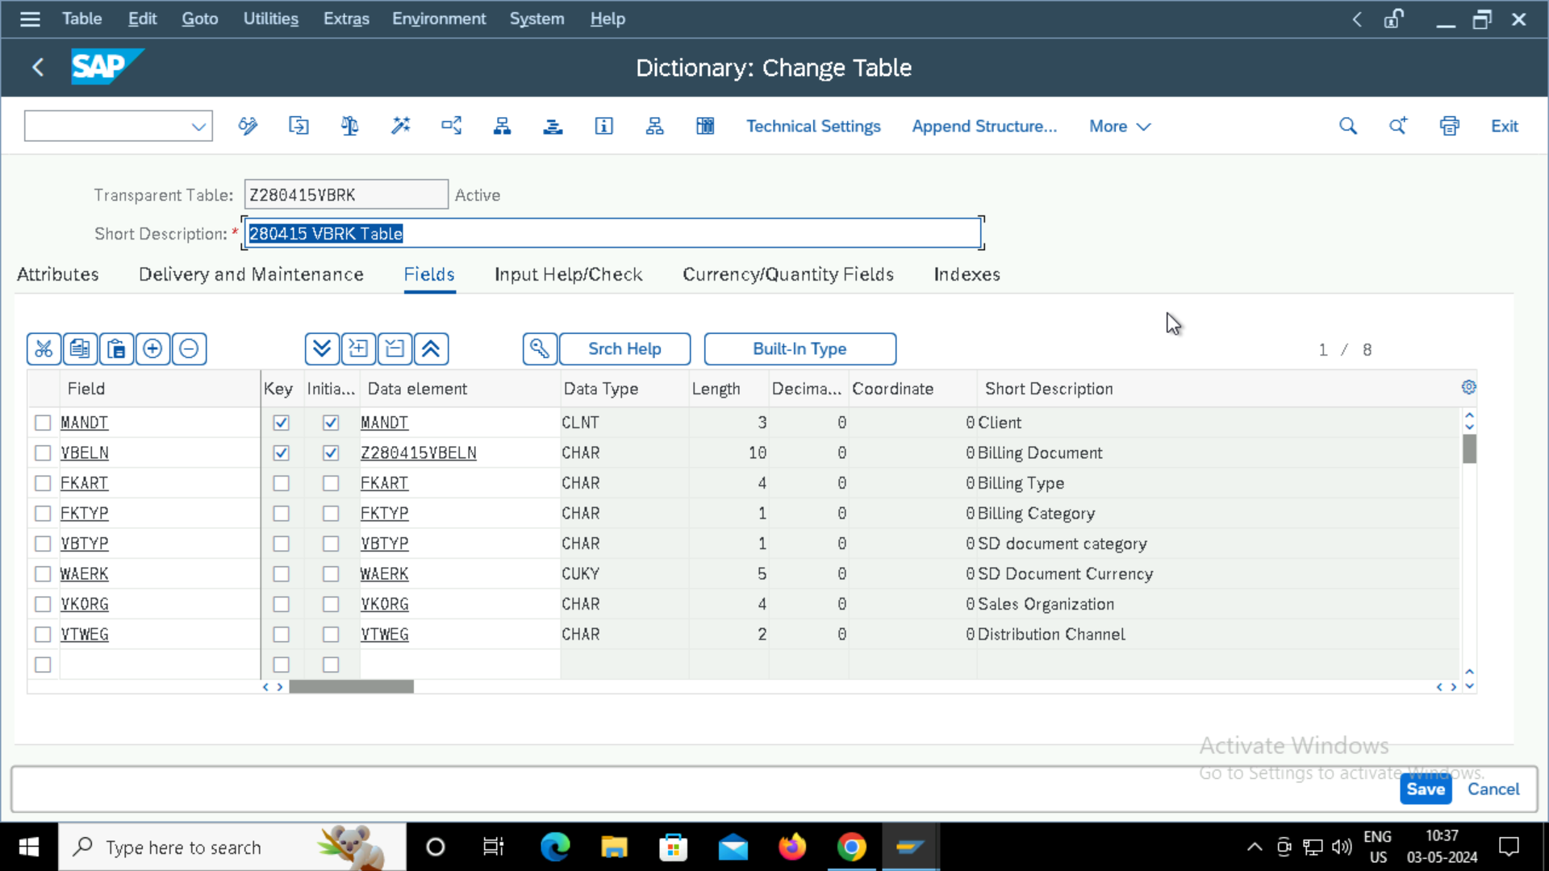

Output:

